✅ ECONOMICS – SET 1
1(a) Supply – Definition
Supply refers to the total amount of a product that producers are willing and able to sell at different prices in a given time period. It shows the producer's side of the market. Supply increases when the price increases because producers can earn more profit. It also depends on production cost, technology, and number of sellers. Higher price generally motivates producers to supply more. So, supply is the relationship between price and quantity producers offer for sale.

1(b) Supply Curve
A supply curve is a graphical representation of the relationship between price and quantity supplied. It usually slopes upward from left to right, meaning higher price leads to higher supply. The curve is drawn by plotting different prices on the Y-axis and quantities supplied on the X-axis. The upward slope shows a direct or positive relationship. It helps in understanding how producers react to price changes. It is important for businesses and policymakers to predict production levels.
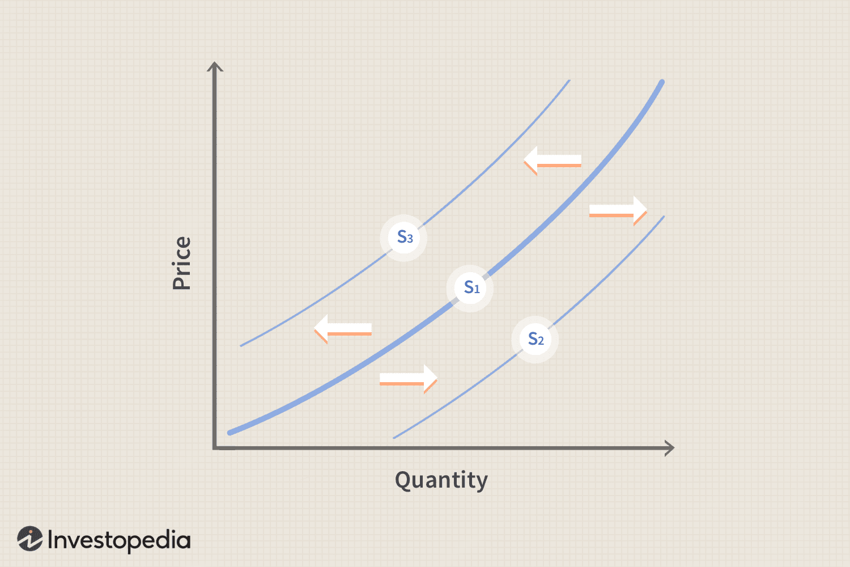

1(c) Law of Supply
The law of supply states that, other things remaining constant, the quantity supplied of a product increase when the price increases, and decreases when the price decreases. This happens because higher price gives producers higher profit per unit. So, they become more willing to produce more. This law assumes that factors like cost, technology, and number of firms stay unchanged. Therefore, price and supply always move in the same direction.

✅ ECONOMICS – SET 2
2(a) Demand – Definition
Demand refers to the quantity of a product that consumers are willing and able to buy at different prices in a given time. It shows the consumer’s side of the market. Demand depends on income, taste, price of related goods, and future expectations. When price increases, consumers buy less. When price decreases, consumers buy more. So demand reflects the relationship between price and the amount consumers want to purchase.

2(b) Demand Curve
A demand curve is a graph that shows the relationship between price and quantity demanded. It slopes downward from left to right, indicating an inverse relationship. We place price on the Y-axis and quantity demanded on the X-axis. The downward slope means people buy more when price falls and buy less when price rises. It helps businesses make pricing decisions and predict consumer behavior. The curve is based on the law of demand.
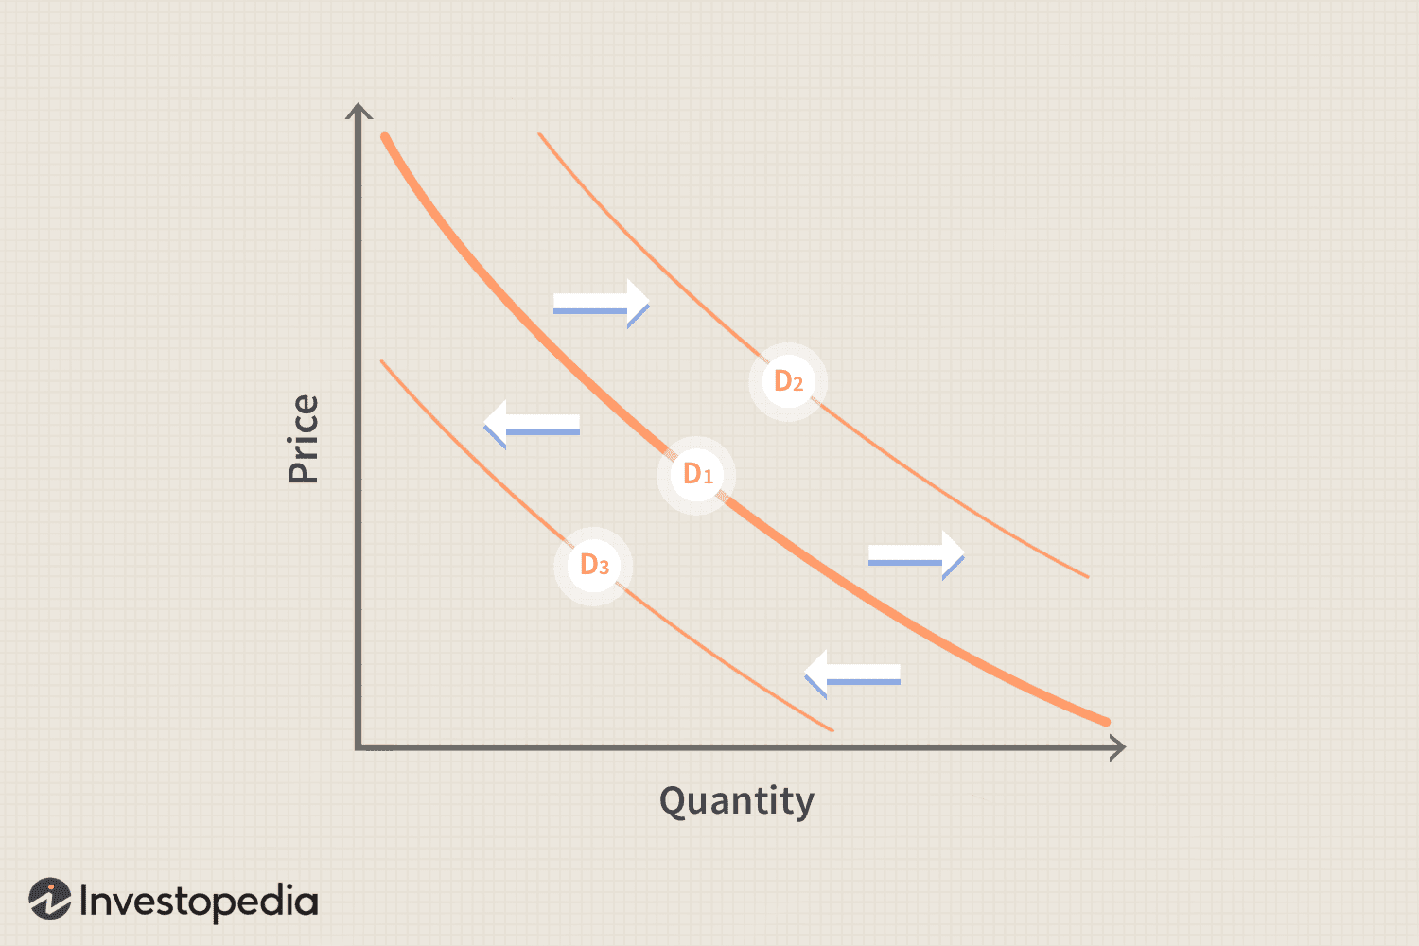

2(c) Law of Demand
The law of demand says that, other things remaining constant, the quantity demanded decreases when price increases, and increases when price decreases. This happens because higher prices reduce consumers' purchasing power. Also, people switch to substitutes. The law assumes income, taste, and population remain unchanged. It shows an inverse relationship between price and demand. That is why demand curves slope downward.

✅ ECONOMICS – SET 3
3(a) GDP – Definition
GDP (Gross Domestic Product) is the total value of all final goods and services produced inside a country during one year. It measures a nation’s economic performance. Only final goods are counted to avoid double counting. GDP includes production by both local and foreign companies inside the country. It helps government and economists understand growth, income level, and economic health. A higher GDP means higher economic activity.

3(b) Rules of GDP Calculation
- Only final goods are counted
- Only goods produced within the country
- Only production within a specific year
- Count only legal goods and services
- No double counting of intermediate goods
- Market price must be used
- Foreign firms inside the country are included

3(c) GDP – How to Count (Example Math)
GDP = C + I + G + NX
Component | Description | Amount
C | Consumption | 500
I | Investment | 200
G | Government Spending | 150
NX | Net Export (Export – Import) | 50
GDP = 500 + 200 + 150 + 50 = 900

3(d) GNP – Definition
GNP (Gross National Product) is the total value of goods and services produced by the citizens of a country in one year, no matter where they are located. It includes income earned by citizens working abroad and excludes income earned by foreigners inside the country. GNP shows how much income the nation’s people generate globally. It is useful for understanding national income and economic strength.

3(e) Rules of GNP Calculation
- Include income earned by nationals anywhere
- Exclude income earned by foreigners inside the country
- Count only final goods
- Count only legal production
- Must be within one year
- Avoid double counting

3(f) GNP – How to Count (Example Math)
Item | Amount
GDP | 900
Income from citizens working abroad | +40
Income earned by foreigners inside the country | –20
GNP = 900 + 40 – 20 = 920

3(g) Difference Between GDP and GNP
GDP (Gross Domestic Product) | GNP (Gross National Product)
GDP measures the total value of all final goods and services produced inside a country’s geographical boundary in one year. | GNP measures the total value of all final goods and services produced by the nationals of a country, whether they are inside or outside the country.
It focuses on location of production. Anything produced within the country’s borders is counted. | It focuses on nationality. Anything produced by the country’s citizens is counted, even if produced abroad.
Income produced by foreigners inside the country is included in GDP. Example: a foreign company producing in Bangladesh adds to Bangladesh’s GDP | Income produced by foreigners inside the country is excluded from GNP because they are not nationals.
Income of citizens working abroad is not included in GDP, because the production is outside the country. | Income of citizens working abroad is included in GNP, because they are nationals of the country.
GDP shows the economic activity happening within the domestic economy and indicates how active local industries and companies are. | GNP shows the total income generated by the nation’s people globally, which helps measure national earning power.
It is used to understand internal economic performance, productivity, and domestic growth. | It is used to understand overall national income, global earning capacity, and economic strength of the citizens.
Formula: GDP = C + I + G + (X – M) | Formula: GNP = GDP + income from citizens abroad – income of foreigners inside the country
A higher GDP means the country’s internal economy is strong and producing more goods and services. | A higher GNP means the country’s citizens are earning more overall, even from international sources.

